

Natural Capital Protocol
User Templates
13 July 2016

Note to user:
These user templates are designed to help structure your outputs for each Step of the Natural Capital Protocol. You are invited to adapt and add to the tables in this document, to fit to your needs and objectives.
The hypothetical example, running throughout the Protocol, may also offer some inspiration and illustration of how to approach the Steps.

Step 01: Get started

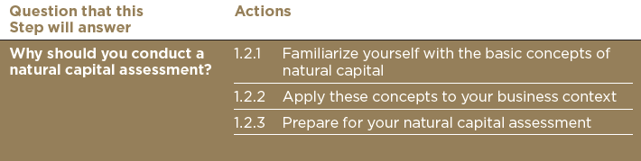

Outputs that you should achieve from this Step:
- An understanding of the basic concepts of natural capital
- Initial ideas about which natural capital impacts and/or dependencies might present risks or opportunities for your business, now or in the future.
- Potential applications of your assessment results.
- In principle, support for the assessment from key business stakeholders.
- Initial understanding of the resources needed to carry out a natural capital assessment (to be refined in subsequent steps).

Templates that can help you reach these outputs:
- How do the concepts of natural capital apply to your business context? What impacts and dependencies are you aware of already, and how might these manifest into risks and/or opportunities? Think about your context now, and in the future. Table 1.1 offers some examples.
- List the potential applications of your assessment results. Table 1.2 offers some examples.
- Which internal stakeholders could you approach for support, and why?
- Using table 1.3 of indicative resources, what will you need to plan for your assessment?

Step 02: Define the objective

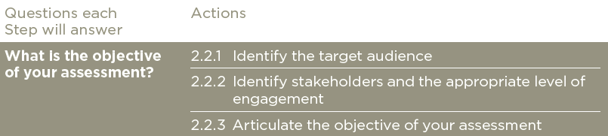

Outputs that you should achieve from this Step:
- The defined audience who will ultimately consider and apply the results of the assessment
- A stakeholder list and appropriate level of engagement
- The specific benefits you anticipate from the assessment
- Building on the above, you should have a defined objective for your natural capital assessment.

Templates that can help you reach these outputs:
- Who is the target audience?
- Who are the right stakeholders, and what is the appropriate level of engagement for each?
- What specific benefits do you anticipate from the assessment?
- What is the specified objective?

Step 03: Scope the assessment
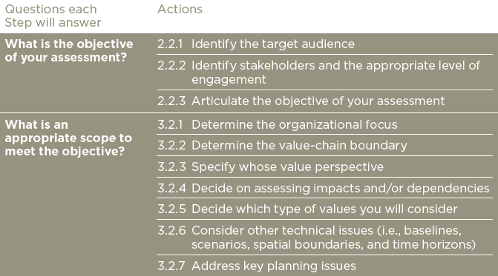

Outputs that you should achieve from this Step:
- A well-defined scope, that is appropriate for your assessment and objective

Templates that can help you reach these outputs:
- What is your organizational focus?
- What is your value-chain boundary?
- What is your value perspective?
- What types of value?
- Are you assessing impacts and/or dependencies? (Component)
- What other technical issues do you need to consider? For example:
  - Baselines
  - Scenarios
  - Spatial boundary
  - Temporal boundary
- What key planning issues will you need to consider?

Step 04: Determine the impacts and/or dependencies
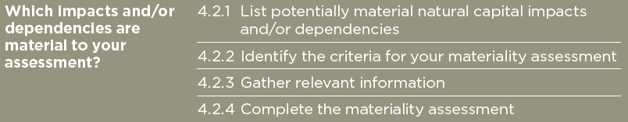

Outputs that you should achieve from this Step:
- A prioritized list of material impacts, dependencies and changes in natural capital to include in your assessment.

Templates that can help you reach these outputs:
Which impact and/or dependency pathways are potentially material to your business? (See Table 4.3 for a detailed example)?
Which criteria will you use for your materiality assessment?
Which internal and/or external stakeholders will you engage in your materiality assessment?

 | Material issues
Materiality Criteria | Issue 1 | Issue 2 | Issue 3 | Expand as required
e.g. operational | Low/medium/high
e.g. legal and regulatory
e.g. financing
e.g. reputational and marketing
e.g. societal
To include in assessment? | Yes/No | Yes/No | Yes/No | Yes/No

Step 05: Measure impact drivers and/or dependencies

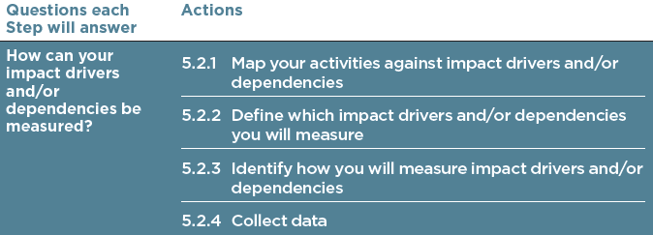

Outputs that you should achieve from this Step:
- A list of indicators for each material impact driver and/or dependency associated with the chosen business activities, in accordance with the chosen organizational focus and value-chain boundary.
- Available data and data gaps identified

Templates that can help you reach these outputs:
Material issue | Impact driver/dependency | Indicator | Data source | Data gaps / key uncertainties
Issue 1
Issue 2
Issue 3
Expand as required

Material issue | Indicator | Intermediate indicator if applicable | Data point
Issue 1
Issue 2
Issue 3
Expand as required

Step 06: Measure changes in the state of natural capital
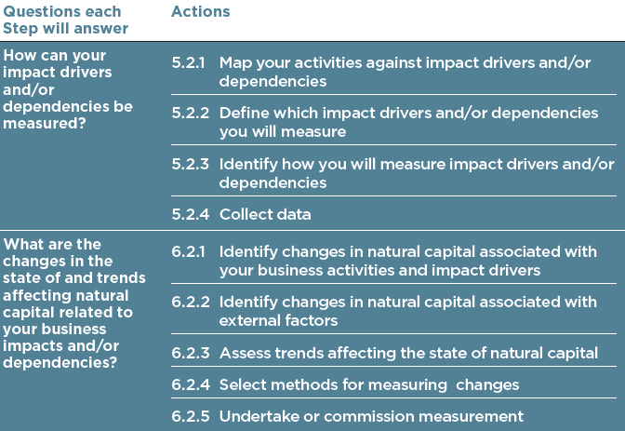

Outputs that you should achieve from this Step:
- A list of the changes in natural capital that are material to your business, in relation to your impacts and/or dependencies, based on your chosen organization focus and value chain boundary. These changes should be expressed through qualitative or quantitative data.
- Likelihood-weighted estimates of change, where relevant.

Templates that can help you reach these outputs:
Material issue | Change in natural capital | Method to measure change | Indicator for change | Data source | Data gaps / key uncertainties | Summary of findings
Issue 1
Issue 2
Issue 3
Expand as required

Step 07: Value impacts and/or dependencies
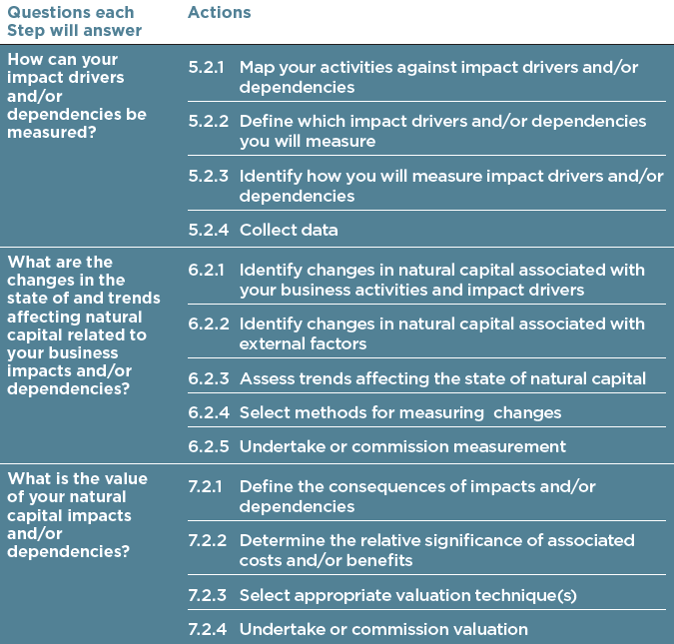

Outputs that you should achieve from this Step:
- A completed valuation (whether qualitative, quantitative or monetary) of costs and benefits
- Documentation of all key assumptions, sources of data, methods used, and resulting values

Templates that can help you reach these outputs:
Planning to value
Issue | Consequences of impact or dependency on business or society (depending on choice of component) | Chosen valuation technique
Issue 1
Issue 2
Issue 3
Expand as required

Results of valuation
Issue | Value to the business  (If applicable to scope) | Value to society  (if applicable to scope)
Issue 1
Issue 2
Issue 3
Expand as required

If considering potential values in the future, you may also choose to add a column for probability-weighted future values. See table 7.3 for an example.
Step 08: Interpret and test the results

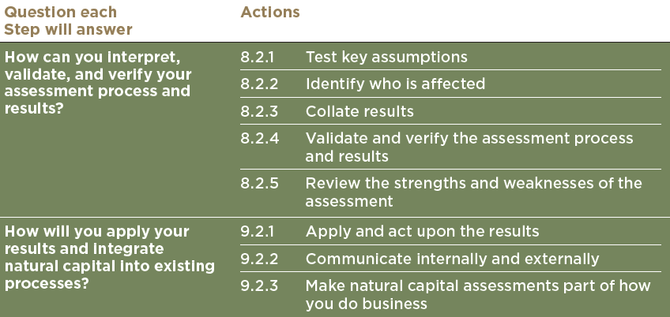

Outputs that you should achieve from this Step:
A summary of:
- Key messages, caveats, assumptions, and uncertainties, including the results of sensitivity analysis if appropriate.
- Output(s) from validation and internal/external verification (if appropriate) of the assessment process and results, including an objective acknowledgement of key assumptions and uncertainties around the results.
- Notes on the review process itself, including how critical assumptions were tested, what level of confidence was deemed necessary, and why.

Templates that can help you reach these outputs:
- What are the findings after testing key assumptions and conducting a sensitivity analysis? What does this imply for your level of confidence, and how the results can be interpreted, communicated and used?
- What were the key strengths of your assessment?
- What were the key weaknesses of your assessment?
- With who, and how, will you share these learnings and conclusions?

Step 09: Take Action

Outputs that you should achieve from this Step:
- Actions that you will take as a result of the assessment
- A communication plan
- A plan for making natural capital assessments part of how you do business.

Templates that can help you reach these outputs:
Material issue | How will you apply and act upon the result?
Issue 1
Issue 2
Issue 3
Expand as required

